BUGASSIGNED:

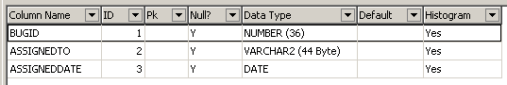

BUGS:

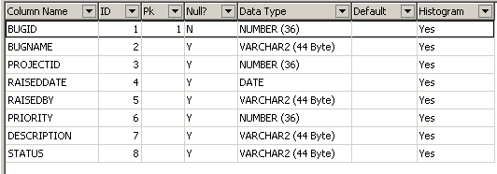

LOGINAUDIT:

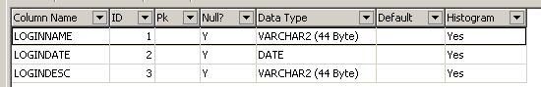

LOGINDETAILS:

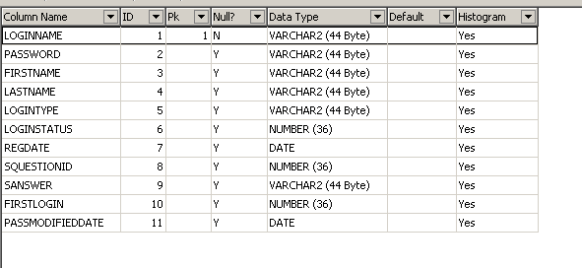  
LOGINPROFILE:

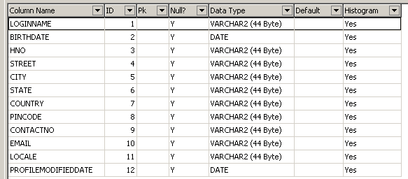

PRIORITY:

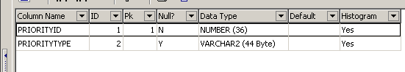

PROJECT:

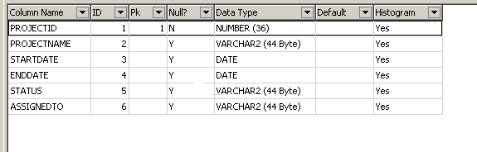

PROJECTMEMBERS:

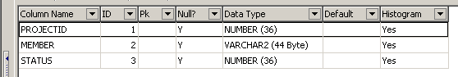

QUESTIONBASE:

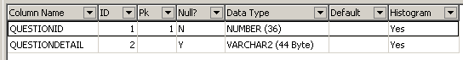

SOLUTION:

